

**REPORT FOR**

AS A PROJECT WORK FOR THE COURSE

**PYTHON PROGRAMMING (INT 108)**

**NAME:** RAGHAV GUPTA **SUBMITTED TO: Ms.Manbir Kaur**

**REGISTRATION NUMBER:** 12215792  **DATE OF SUBMISSION:30/12/22**

**ROLL NUMBER:** RKOC05B46

**SEMESTER:** FIRSTSEMESTER

**SCHOOL OF COMPUTER SCIENCE AND ENGINEERING**

**LOVELY PROFESSIONAL UNIVERSITY, JALANDHAR, PUNJAB, INDIA.**

**DECLARATION**

This is to declare that this report has been written by us. No part of the report is copied from other sources. All information included from other sources have been duly acknowledged. We aver that any part of the report is found to be copied, we are shall take full responsibility for it.



RAGHAV GUPTA

Roll number: 46

Place

date

**INDEX**

|  |  |  |
| --- | --- | --- |
| **SNO** | **Chapter** | **Page No** |
| 1.1 | Introduction | 4 |
| 1.2 | Loops/Function/Module | 4-5 |
| 1.3 | Project | 5-6 |
| 1.4 | Code | 6-7 |
| 1.5 | Results | 8 |

**PYTHON**

* 1. **INTRODUCTION:**

[Python](https://www.geeksforgeeks.org/python-programming-language/) is a widely used general-purpose, high level programming language. It was initially designed by Guido van Rossum in 1991 and developed by Python Software Foundation. It was mainly developed for emphasis on code readability, and its syntax allows programmers to express concepts in fewer lines of code.

Python is a programming language that lets you work quickly and integrate systems more efficiently.

Python is a high-level, interpreted, interactive and object-oriented scripting language. Python is designed to be highly readable. It uses English keywords frequently where as other languages use punctuation, and it has fewer syntactical constructions than other languages.

**Python is Interpreted** − Python is processed at runtime by the interpreter. You do not need to compile your program before executing it. This is similar to PERL and PHP.

**Python is Interactive** − You can actually sit at a Python prompt and interact with the interpreter . directly to write your programs

**Python is Object-Oriented** − Python supports Object-Oriented style or technique of programming that encapsulates code within objects.

**1.2 LOOPS/FUNCTION/MODULE:**

* **Import** − In Python, you use the import keyword to make code in one **module** available in another. Imports in Python are important for **structuring your code** effectively. Using imports properly will make you more productive, allowing you to reuse code while keeping your projects maintainable.
* **Random module** − Python **Random module** is an in-built module of Python which is used to generate random numbers. These are pseudo-random numbers means these are not truly random. This module can be used to perform random actions such as generating random numbers, print random function a value for a list or string, etc.
* **Input** −The input function is used to ask the user of the program (not the programmer) a question, and then wait for a typed response. The typed number is then returned as the result of the function, and should usually be stored in a variable: age = input('how old are you: ').
* **Int function** − The int() function converts the specified value into an integer number.
* **Random.randint** − The randint() method returns an integer number selected element from the specified range.
* **If-else condition** − The if-else statement is used to execute both the true part and the false part of a given condition. If the condition is true, the if block code is executed and if the condition is false, the else block code is executed.
* **For loop** − The for loop in Python is used to iterate over a sequence, which could be a list, tuple, array, or string. The program operates as follows: We have assigned a variable, x, which is going to be a placeholder for every item in our iterable object.
* **Break statement** − 'Break' in Python is **a loop control statement**. It is used to control the sequence of the loop. Suppose you want to terminate a loop and skip to the next code after the loop; break will help you do that. A typical scenario of using the Break in Python is when an external condition triggers the loop's termination.
* **Arithmetic operators** − There are 7 arithmetic operators in Python :

Addition,Subtraction,Multiplication,Division,Modulus,Exponentiation,Floor division.

* **Logical operators** − The operators include: > , < , >= , <= , === , and !== . Logical operators — operators that combine multiple boolean expressions or values and provide a single boolean output.

**1.3 PROJECT :**

In this project we have to enter a range [A, B] and system will randomly pick any number from our given range and check the status of that given number.

The properties to be checked are:

1. Is that number is odd or even
2. Is that number is positive or negative number
3. Is that number is prime number or composite number.

After checking the status, you have to display all the properties followed by the randomly picked number.

For example

Range is (1,12) and randomly picked number is 10

Then the properties followed by this number are:

10 is a positive number

10 is an even number

10 is a composite number

(we are free to decide the input and output layout for this mini project)

**1.4 CODE:**

import random

print("<--PROGRAM FOR IDENTIFYING THE PROPERTIES OF A RANDOM NUMBER BETWEEN A RANGE-->")

print()

a = int(input('Enter the starting range : '))

b = int(input('Enter the ending range : '))

c = random.randint(a,b)

print(f'Range is ({a},{b}) and the randomly picked number is {c}')

print()

print("Properties---->")

if c%2 == 0:

print(f'{c} is an even number.')

else:

print(f'{c} is an odd number.')

if c > 0:

print(f'{c} is a positive number.')

else:

print(f'{c} is a negative number.')

flag = False

if c > 1:

for i in range(2,c):

if (c%i) == 0:

flag = True

break

if flag:

print(f'{c} is a composite number.')

else:

print(f'{c} is a prime number.')

**screenshot of code:**

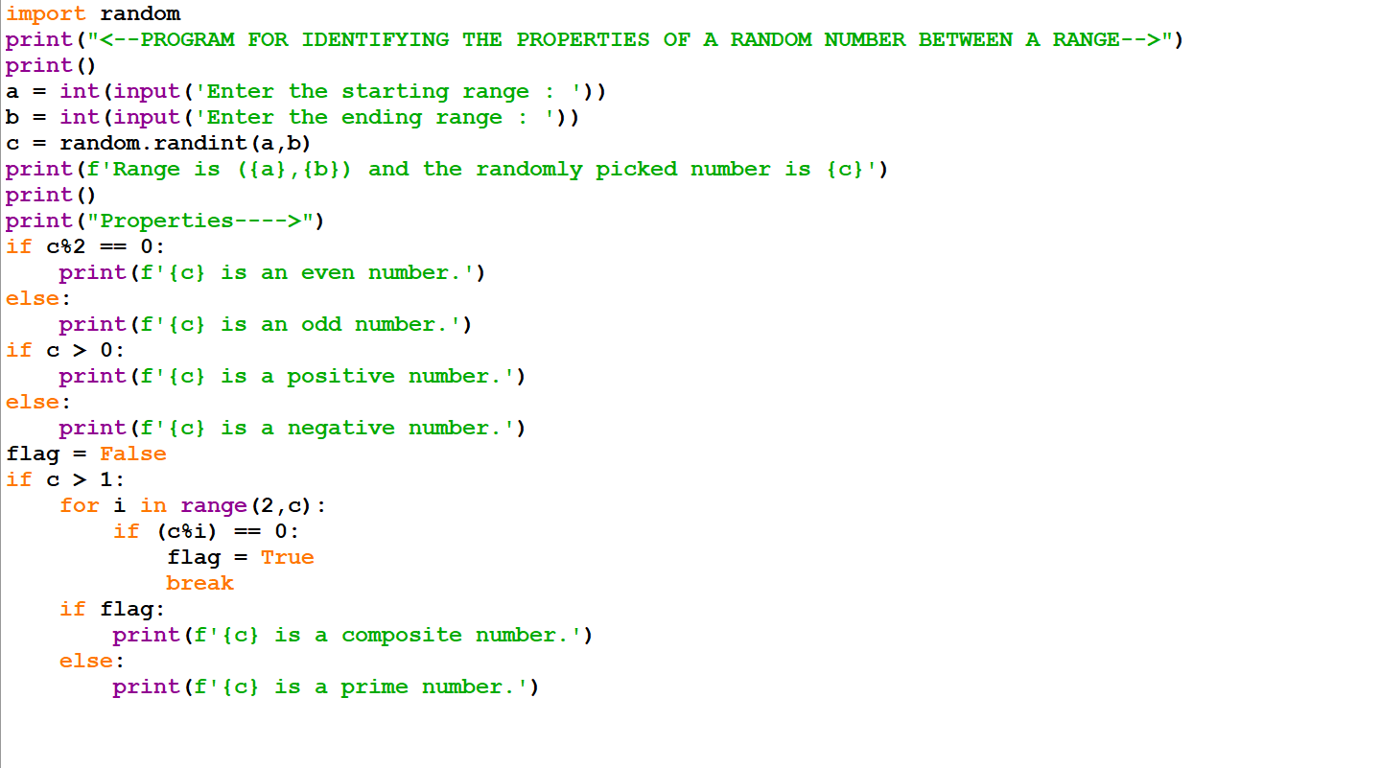

**1.5 RESULTS:**

